6.77: Denote the initial compression of the spring by x and the distance from the initial position by L. Then, the work done by the spring is 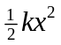 and the work done by friction is 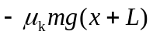; this form takes into account the fact that while the spring is compressed, the frictional force is still present (see Problem 6.76). The initial and final kinetic energies are both zero, so the net work done is zero, and 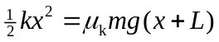. Solving for L,
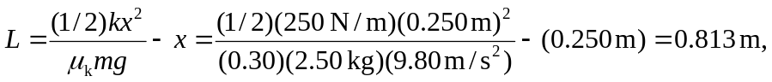
or 0.81 m to two figures. Thus the book moves 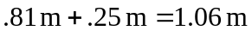, or about 1.1 m.

